DNA Extraction from Kiwi Fruit

Equipment:

* 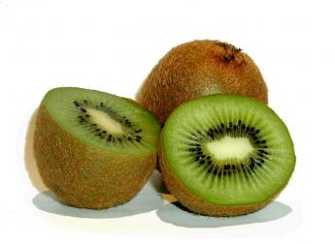1 kiwi fruit
* Zip-lock bag
* DNA extraction buffer (10% detergent and salt)
* 250mL beaker
* Small strainer
* 100mL beaker
* Test tube
* Chilled ethanol
* Wooden skewer

1. Chop up kiwi fruit and place in the zip lock bag. Squeeze out the air and then seal the bag.
2. Gently squash the kiwi fruit with your fingers, until it is a soft paste.
3. Open the bag and pour in about 20mL of DNA extraction buffer. Seal the bag and mix the solution thoroughly.
4. Leave the bag to sit for 5 minutes.
5. Filter the mixture through the strainer over a 250mL beaker.
6. Pour the kiwi fruit solution into the 100mL beaker.
7. Half fill a test tube with chilled alcohol.
8. Tilt the 100mL beaker and slowly, gently pour the alcohol down the side of the beaker. The alcohol should form a layer on top.
9. Leave the beaker for a few minutes.
10. You should see a white substance forming. Dip the wooden skewer into the beaker and slowly twirl it to collect the substance. This is the DNA of the kiwi fruit.